**CHALLENGES IN URBAN PLANNING OF KOLKATA**

**Submitted by**

**BIPASHA GHOSH**

**Class Roll No: 002110401056**

**BCE IV; Section A3**

**Second Semester; Session 2024-25**

**Under the Supervision of**

**Dr. GUPINATH BHANDARI**

**Professor**

**Department of Civil Engineering**

**Jadavpur University**

**Kolkata 700032, INDIA**

**April 2025**

**ACKNOWLEDGEMENT**

I owe my most sincere thanks and profound gratitude for the indispensable advice and inspiration rendered by the supervisor, **Prof. Gupinath Bhandari** at each phase of the project work. Thank you for providing me with such an opportunity to work on such a topic and directing me with your knowledge and experience in many long discussions on various topics related to my project.

I would also like to take this opportunity to express my gratefulness to all the respected teachers of Civil Engineering Department of Jadavpur University for their valuable suggestions and for their continuous support and to all the beloved classmates for their continuous inspiration, assistance and cooperation to pursue this project work.

Again, I would like to thank Prof. Gupinath Bhandari for providing various references and resources to refer to which helped in the completion of my project. I would like to always express my gratitude to my family for their unconditional support and prayers.

Finally, I am thankful to the Almighty and to all those whose efforts either directly or indirectly have contributed well during this project work.

**Date:**

**BIPASHA GHOSH**

**Class Roll No: 002110401056**

**BCE IV; Section A3; Second Semester;**

**Session 2024-25**

**CERTIFICATE OF APPROVAL**

This is to certify that Ms **BIPASHA GHOSH**, bearing Class Roll No: **002110401056**, a Student of BCE IV, Second Semester, Session 2024-25, in the Department of Civil Engineering, Jadavpur University, Kolkata 700032, have carried out the job and submitted the *Completed Report* of the **Major Project** entitled “***CHALLENGES OF URBAN PLANNING IN KOLKATA***”. The time span of this Major Project has been given for Two Semesters. The time schedule for activity was planned accordingly. The *Interim Report*, the first part of the report was planned to cover a small introduction, literature review, identification of problem, objective of the present project work, scope of work, and methodology, and the same was submitted and presented at the end of the First Semester, Session 2024-25. This present report continuing the previous one incorporating the result and discussion, & concluding remarks, however the list of reference is to be included from the very beginning. The present report has been prepared by Ms **GHOSH** with a guidance from the undersigned, on her own, by studying the available literature, which has been referred.

It appears that the submitted report was prepared on the basis of fundamental theory and real world information/ data. The assembling of those theory and information was carried out on the basis of the implementation in different literature. The study of those literature enriched the report on the Major Project.

This report has been submitted for the partial fulfilment of the requirement for completion of the Second semester course work of BCE IV for completion of the undergraduate degree is a record of bonafide project work carried out by her, under my direct supervision and guidance.

So far my knowledge goes, the present project work contained in this report has not been submitted by Ms **GHOSH**, in part or full to any other university or institution or professional body for the award of any degree or diploma.

Date:

Signature of the Supervisor

______________________

Dr. GUPINATH BHANDARI

Professor, Department of Civil Engineering

Jadavpur University, Kolkata 700032, INDIA.

**TABLE OF CONTENTS**

|  |  |
| --- | --- |
| **TOPICS** | **PAGE NUMBERS** |
| INTRODUCTION | 5 |
| LITERATURE REVIEW | 7 |
| PROBLEMS IDENTIFIED | 9 |
| OBJECTIVES | 14 |
| SCOPE | 16 |
| METHODOLOGY | 18 |
| RESULT & DISCUSSION | 32 |
| CONCLUDING REMARKS | 40 |
| REFERENCES | 41 |
| WORK SCHEDULE | 44 |

**INTRODUCTION:**

Kolkata, as one of India's oldest metropolitan cities, faces unique challenges in its urban transport system. The city showcases a blend of traditional and contemporary transport modes from the colonial tram network to the modern Metro expansion. However, congestion, inadequate last-mile connectivity, and rising pollution necessitate a comprehensive review and reform of its transport planning.

**Importance of Efficient Urban Planning in Transportation for Growing Cities**

1. **Reduced Congestion:** Well-planned transport systems minimize traffic bottlenecks, ensuring smoother commutes.
2. **Economic Growth:** Efficient mobility supports trade, business, and employment opportunities.
3. **Environmental Benefits:** Promotes public transportation and non-motorized travel, reducing carbon emissions.
4. **Enhanced Quality of Life:** Decreases travel time and stress, improving overall urban living conditions.
5. **Sustainability:** Integrates green solutions like EVs and efficient land use to accommodate urban expansion.

**Overview of Kolkata’s Urban Transport System**

Kolkata boasts a diverse urban transport network with a mix of traditional and modern systems:

* **Metro Rail:** India’s first metro system, operational since 1984, with ongoing expansions to ease connectivity across the city and suburbs.
* **Trams:** The oldest electric tram system in Asia, though its usage has declined due to inefficiency.
* **Buses:** A wide network of government and private buses, though overcrowding and aging vehicles are common issues.
* **Ferries:** Serve as an alternative mode of transport across the Hooghly River, reducing road congestion.
* **Yellow Taxis and App-Based Services:** Traditional taxis coexist with app-based cab and bike services.
* **Auto-Rickshaws:** Essential for short-distance travel within neighbourhoods.

**Challenges in Kolkata’s Urban Transport System**

**1. Traffic Congestion:**

* Kolkata’s road network is characterized by narrow streets and mixed traffic. The lack of dedicated lanes for public transport, bicycles, and pedestrians exacerbates congestion.
* Encroachments on roads and unauthorized parking further reduce the city’s carrying capacity during peak hours.

**2. Pollution:**

* Kolkata suffers from poor air quality, driven by emissions from aging buses, autos, and taxis that use outdated fuel technologies.
* The reliance on private vehicles increases vehicular pollution, especially in high-density areas.
* Inefficient waste management near transport hubs, such as bus depots and metro stations, contributes to environmental degradation.

**3. Outdated Infrastructure:**

* Roads, bridges, and tramlines suffer from inadequate maintenance, leading to frequent breakdowns and disruptions.
* Kolkata’s tram system, though iconic, lacks the speed and efficiency required for modern commuting needs.
* Drainage and waterlogging issues during monsoons often damage road infrastructure, making transport unsafe and inconvenient.

**4. Inadequate Public Transport Options:**

* Public buses and metro trains often operate at full capacity, leaving many commuters to depend on private vehicles or autos.
* Last-mile connectivity remains a significant gap, as many areas lack adequate feeder services to metro stations and bus stops.

**5. Environmental Impact:**

* Urban development projects, such as flyovers and new roadways, have encroached upon the East Kolkata Wetlands and other green spaces, threatening biodiversity and increasing the city’s vulnerability to flooding.

**LITERATURE REVIEW:**

The urban landscape of Kolkata has been extensively studied, revealing a complex interplay of historical, social, and infrastructural factors that shape its development. This literature review synthesizes key findings from various studies, highlighting the challenges faced in urban planning within the city.

**1. Urban Growth and Population Dynamics**

Kolkata, with its high population density, particularly in older neighborhoods such as Bhowanipore and Dhakuria, faces significant challenges related to overcrowding and resource distribution. Research indicates that the rapid urbanization has led to a strain on existing infrastructure, resulting in inadequate services and increased pressure on housing and transportation systems . The demographic shifts, characterized by migration and urban sprawl, further complicate planning efforts, necessitating a comprehensive understanding of population dynamics to inform policy decisions.

**2. Transportation Infrastructure**

The transportation network in Kolkata is a mix of traditional and modern modes, including trams, buses, auto-rickshaws, and the metro system. However, the rapid increase in vehicle numbers, particularly unregulated services like "totos," has exacerbated traffic congestion, especially in peripheral areas . Studies emphasize the need for an integrated approach to transportation planning that considers sustainable practices and addresses environmental concerns, such as air quality and urban flooding. The literature suggests that improving public transport accessibility and regulating informal transport services are critical for enhancing mobility and reducing congestion.

**3. Environmental Concerns**

Kolkata's urban planning is also challenged by environmental issues, including flooding and biodiversity loss. The city's vulnerability to climate change impacts, such as rising sea levels and extreme weather events, necessitates the incorporation of resilience strategies in urban planning. Research highlights the importance of green spaces and sustainable drainage systems to mitigate flooding risks and enhance urban biodiversity. The literature advocates for policies that prioritize environmental sustainability alongside urban development.

**4. Community Engagement and Inclusivity**

The role of public engagement in urban planning is increasingly recognized as vital for creating inclusive urban environments. Studies indicate that community-driven initiatives can significantly enhance urban design and transport systems, fostering a sense of ownership among residents . Recommendations include improving pedestrian infrastructure and promoting participatory planning processes to ensure that the needs of diverse communities are met.

**5. Case Studies and Localized Solutions**

Localized studies of specific neighbourhoods reveal significant disparities in transport accessibility and community cohesion. For instance, while areas like Salt Lake and Sukhobrishti are well-planned, they face connectivity challenges, whereas densely populated neighbourhoods like Bhowanipore experience high pedestrian and vehicular activity, leading to frequent conflicts. This underscores the necessity for tailored solutions that address the unique characteristics of each neighbourhood, rather than a one-size-fits-all approach.

**6. Implementation process**

The implementation process of urban planning in Kolkata necessitates a collaborative approach involving government agencies, private sector partners, and community organizations. Key to this process is stakeholder engagement, which ensures that local communities have a voice in shaping solutions that address their specific needs. Establishing a robust policy framework that outlines clear goals and strategies is essential, alongside a phased implementation approach that prioritizes projects based on urgency and impact. Continuous monitoring and evaluation are vital for assessing the effectiveness of initiatives, while public-private partnerships can enhance resource mobilization and innovation. By integrating these elements, the implementation process can be streamlined, fostering effective urban development that aligns with Kolkata's growth and sustainability objectives.

**7. Comparative Urban Structures Across Indian Metros**

A comparative analysis of Indian metropolitan cities reveals that Kolkata has one of the lowest ratios of road length to vehicular load and land area. Cities like Delhi and Bengaluru exhibit a more hierarchical and expansive road network, with better major road penetration. This gap highlights how Kolkata’s spatial and infrastructural constraints have historically limited large-scale transport interventions, unlike its peer metros which demonstrate greater adaptability to modern urban pressures.

**8. Direction of Present Research**

Building on this body of literature, the present study undertakes a comparative spatial analysis of major Indian cities to contextualize Kolkata’s transport network within broader national patterns. It further integrates findings from the NLUC framework and visual data analytics to critically examine the role of road infrastructure, public transport capacity, and planning deficits in shaping the urban experience in Kolkata. This approach aims to generate actionable insights for future transport and development policies in the city.

**Summary of Literature Review**

The literature on urban planning in Kolkata underscores the multifaceted challenges the city faces, from infrastructural inadequacies to environmental vulnerabilities and social disparities. A comprehensive approach that integrates sustainable practices, community engagement, and localized solutions is essential for addressing these challenges and fostering a resilient urban future.

**PROBLEM IDENTIFIED:**

**1. Traffic Congestion in Key Areas**

Kolkata faces persistent traffic congestion in several key areas due to high vehicular density, inadequate infrastructure, and poor traffic management.

* **Esplanade:**
  + A historic and commercial hub, Esplanade is a nexus for buses, taxis, private cars, and trams. The area is perpetually clogged with traffic, worsened by unauthorized parking and the presence of street vendors encroaching on sidewalks and road spaces.
  + Narrow roads and the convergence of multiple routes make traffic flow erratic, particularly during peak hours. Efforts to streamline traffic through flyovers have only partially alleviated the problem.
* **Howrah:**
  + Home to Howrah Station, India’s oldest and one of the busiest railway stations, this area experiences immense traffic pressure.
  + The Howrah Bridge and Vidyasagar Setu, two major bridges connecting Howrah and Kolkata, often witness long queues of vehicles during rush hours due to inadequate capacity and poor traffic regulation.
  + Pedestrian movement from the station adds another layer of complexity, with jaywalking frequently disrupting vehicular flow.
* **Salt Lake (Bidhannagar):**
  + Originally a planned township, Salt Lake has rapidly evolved into a commercial and IT hub, particularly in Sector V. The influx of employees, students, and residents has outpaced the capacity of its roads.
  + The absence of a well-organized public transport system and inadequate parking facilities further aggravate congestion, especially during office hours.

**2. Inadequate Integration of Public Transport Modes**

Kolkata’s public transport system, though extensive, lacks effective integration between its various components, including the Metro, buses, trams, ferries, and auto-rickshaws.

* **Disconnected Services:**
  + Commuters often face challenges in transitioning between modes. For instance, someone arriving at Howrah Station may need to rely on shared autos or multiple bus transfers to reach destinations in South Kolkata or Salt Lake.
  + There is no unified ticketing system across modes, requiring passengers to purchase separate tickets and navigate different schedules.
* **Metro and Bus Gaps:**
  + While the Metro system provides rapid transit, its stations are often far from key bus routes, leaving commuters stranded or dependent on informal transport options like auto-rickshaws.
  + Trams, once a major mode of transport, are now largely symbolic and disconnected from the broader network due to route closures and infrastructure decay.
* **Ferry Connectivity:**
  + Ferries offer a sustainable alternative for crossing the Hooghly River, but limited integration with Metro and bus services restricts their potential. For example, passengers disembarking at ferry terminals often find it challenging to connect to other transport systems seamlessly.

**3. Poor Last-Mile Connectivity**

Last-mile connectivity is a significant challenge in Kolkata, limiting the usability of public transport systems.

* **Metro Last-Mile Gaps:**
  + Metro stations like New Garia, Dum Dum, and Noapara lack sufficient feeder services, making it difficult for passengers to reach their final destinations.
  + Informal options such as shared autos and e-rickshaws fill the gap but often operate without regulation, leading to safety concerns and inconsistent pricing.
* **Emerging Areas:**
  + Rapidly growing neighbourhoods like Rajarhat and New Town face acute last-mile connectivity issues. Despite being planned areas, these locations lack adequate public transport options, forcing residents to rely on private vehicles or informal transport systems.
* **Pedestrian and Cycling Infrastructure:**
  + Walkability around major hubs is poor, with broken sidewalks, encroachments, and a lack of designated pedestrian crossings.
  + Cycling, a potentially sustainable mode of transport, is underutilized due to the absence of dedicated lanes and safety concerns.

**4. Environmental Challenges Due to Vehicular Emissions**

Kolkata’s air quality has been steadily deteriorating, driven largely by vehicular emissions from aging and poorly maintained vehicles.

* **Aging Fleet:**
  + Public buses, auto-rickshaws, and taxis often use outdated fuel technologies, contributing significantly to air pollution.
  + Despite efforts to transition to CNG and electric vehicles, the pace of adoption remains slow.
* **Private Vehicle Dependence:**
  + As public transport struggles to meet demand, more residents are turning to private vehicles, exacerbating congestion and emissions.
  + The lack of carpooling initiatives or incentives for shared mobility further intensifies the problem.
* **Loss of Green Spaces:**
  + Infrastructure projects like flyovers and new roads have encroached on the East Kolkata Wetlands and other green areas, reducing the city’s natural ability to absorb pollutants.
  + Noise pollution near high-traffic zones, such as Howrah Station and Esplanade, adds to the environmental stress.

**Specific Case Studies and Examples**

**1. Traffic Bottlenecks**

* **Shyambazar Crossing:**
  + A critical five-point intersection connecting North Kolkata, Shyambazar regularly experiences gridlocks due to mixed vehicle flow and poor signal coordination.
  + Attempts to resolve the issue with flyovers have shifted, rather than solved, the congestion problem.
* **Chingrighata Junction:**
  + Located on EM Bypass, this intersection sees heavy traffic from commuters traveling to Salt Lake and New Town.
  + Frequent accidents and delays result from inadequate pedestrian crossings, poor road design, and high vehicular density.

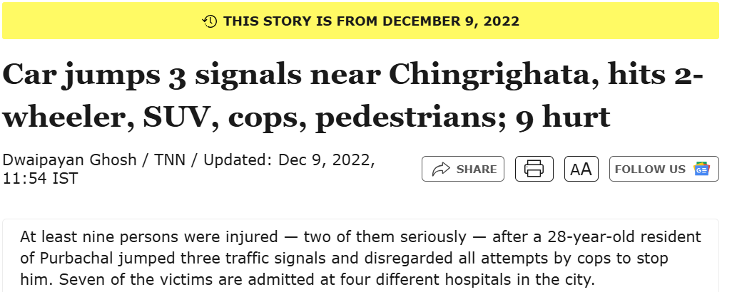

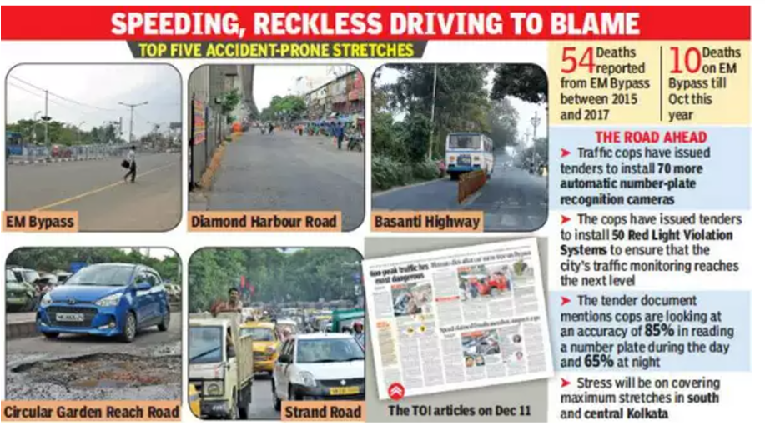

**2. Delays in Metro Expansion**

* **East-West Metro Corridor:**
  + The project, intended to connect Howrah and Salt Lake, has faced delays due to complex tunnelling under the Hooghly River and subsidence incidents in Bowbazar in 2019.
  + The delays have forced commuters to rely on overcrowded buses and private vehicles, aggravating congestion and pollution.
* **Joka-BBD Bag Line:**
  + This proposed Metro line aimed at connecting South Kolkata to central business districts has been delayed for years due to land acquisition issues and slow construction.
  + The lack of progress has left southern neighbourhoods underserved by efficient public transport.

**3. Encroachments on Infrastructure**

* **Esplanade Tram Depot:**
  + The tram depot, a vital hub for Kolkata’s tram network, has been encroached upon by hawkers and informal businesses, reducing its operational efficiency.
  + As a result, trams have become less viable as a transport option, further burdening buses and private vehicles.
* **Howrah Bridge:**
  + Originally designed for non-motorized vehicles, the bridge now endures immense traffic pressure from both passenger and commercial vehicles. Frequent maintenance disrupts traffic, highlighting the need for alternative crossings.

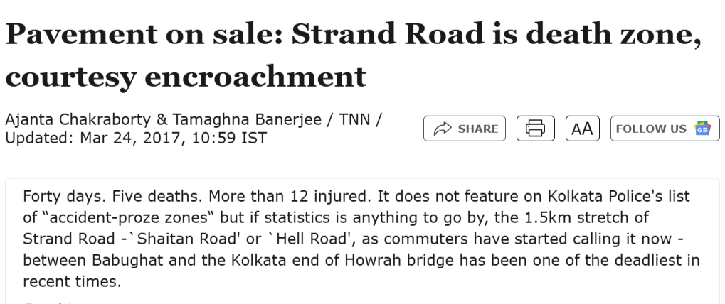

These issues not only hinder mobility but also impact the overall quality of life for residents. Addressing these challenges requires a comprehensive and integrated approach that prioritizes sustainable development, efficient resource allocation, and active community engagement. By recognizing and tackling these problems, Kolkata can pave the way for a more resilient and inclusive urban future.

.

**OBJECTIVES:**

The document aims to provide a **comprehensive analyszeis of urban planning challenges and opportunities in Kolkata** while presenting actionable strategies for addressing these issues. The key objectives are:

**1. Analysing Urban Growth and Population Dynamics**

* **Population Density:** Kolkata faces a significant challenge due to its high population density, particularly in older, central neighbourhoods like Bhowanipore and Dhakuria. The document examines how this density affects living conditions, infrastructure, and resource distribution.
* **Spatial Distribution of Resources:** It highlights the uneven distribution of essential services, housing, and amenities, leading to overcrowding in some areas and underutilization in others.

**2. Promoting Sustainable and Inclusive Urban Development**

* The document emphasizes the importance of sustainability in city planning by addressing:
  + **Environmental Concerns:** Managing green spaces, improving air quality, and addressing urban flooding.
  + **Inclusive Development:** Ensuring equitable access to housing, transportation, and employment opportunities for all socio-economic groups.
  + **Modernization vs. Heritage Preservation:** Striking a balance between preserving the city's historical and cultural identity and modernizing its infrastructure for contemporary needs.

**3. Using Case Studies to Illustrate Key Issues and Solutions**

* The document analyses specific neighbourhoods as case studies:
  + **Bhowanipore and Dhakuria:** Examples of densely populated areas with legacy infrastructure and urban sprawl challenges.
  + **Salt Lake and Sukhobrishti:** Contrasting planned urban spaces and suburban developments that represent potential models for decentralized urban growth.

**4. Proposing Multi-Nodal Development**

* The idea of decentralizing urban development by creating multiple growth nodes, as opposed to a single city centre, is a central theme. These nodes would:
  + Relieve pressure on overburdened central areas.
  + Promote better connectivity across neighbourhoods and suburban regions.
  + Enhance access to resources and opportunities throughout the city.

**5. Providing Policy and Strategic Recommendations**

* The document concludes by offering solutions tailored to Kolkata’s unique urban fabric:
  + **Smart Infrastructure Upgrades:** Investing in technology-driven improvements to transportation, waste management, and water supply systems.
  + **Affordable Housing:** Encouraging public-private partnerships for housing projects catering to low- and middle-income groups.
  + **Cultural and Heritage Preservation:** Policies to protect iconic landmarks, traditional neighbourhoods, and the intangible heritage of the city while fostering growth.

Top of Form

Bottom of Form

**SCOPE:**

**1. Geographical Scope:**

* **Kolkata and its Metropolitan Area:** The primary focus is on Kolkata city and its metropolitan region, including surrounding suburbs and neighbouring towns within the Kolkata Metropolitan Development Area (KMDA).
* **Specific Neighbourhoods and Districts:** The analysis includes case studies of particular areas like Bhowanipore, Dhakuria, Salt Lake, and Sukhobrishti to explore localized urban issues and opportunities.

**2. Timeframe:**

* **Current Challenges and Trends (Present-Day):** The document evaluates present-day urban issues in Kolkata, such as population density, inadequate infrastructure, and uneven distribution of resources.
* **Future Urban Development (20-30 years):** It looks ahead to the next few decades to predict trends in population growth, infrastructure needs, and emerging challenges. The timeframe extends to envisioning a sustainable urban model for Kolkata by 2050.

**3. Thematic Scope:**

* **Urban Growth Patterns:** Focus on understanding Kolkata’s expanding urban fabric and the migration patterns contributing to its growth. This includes demographic changes, population density, and spatial distribution of resources.
* **Sustainability and Green Infrastructure:** Evaluating environmental aspects, such as green spaces, pollution, and flood management, with an emphasis on sustainable urban planning and climate resilience.
* **Urban Mobility and Transportation:** Addressing congestion, public transport systems, and connectivity between suburban areas and the city centre.
* **Housing and Infrastructure Development:** Proposing strategies to tackle housing shortages, slum development, and outdated infrastructure. The scope includes affordable housing and modernizing existing infrastructure.
* **Cultural Heritage Preservation:** Ensuring that the city’s historical and cultural landmarks are preserved while planning for modernization and development.
* **Socio-Economic Inclusivity:** Analysing the urban economy, employment opportunities, and addressing socio-economic disparities in access to essential services.

**4. Strategic and Policy Scope:**

* **Urban Planning Models and Approaches:** The document examines international urban planning practices and adapts them to Kolkata’s context, proposing multi-nodal development as an alternative to the traditional centralization model.
* **Policy Recommendations:** Offering a set of actionable strategies and policies aimed at improving governance, sustainability, urban mobility, housing, and heritage conservation.
* **Governance and Stakeholder Engagement:** The document considers the role of local governance, public-private partnerships, and community participation in shaping the future of Kolkata’s urban landscape.

**5. Exclusion from Scope:**

* **Rural Development:** While the document touches on suburban development, the primary focus is urban areas, so rural planning is not included in-depth.
* **Detailed Economic Modelling:** The document provides a high-level overview of economic challenges and opportunities but does not delve into intricate economic modelling or projections.
* **Global Comparisons Beyond India:** The focus is specifically on Kolkata and India, with references to international practices being limited to urban contexts relevant to Indian cities.

**METHODOLOGY:**

Kolkata's rapid population growth has spurred significant economic activity and cultural exchange. The city's expanding transportation network has facilitated connectivity, enabling people to access opportunities and services across the city. This growth has also led to the development of new infrastructure and amenities, improving the overall quality of life for its residents.

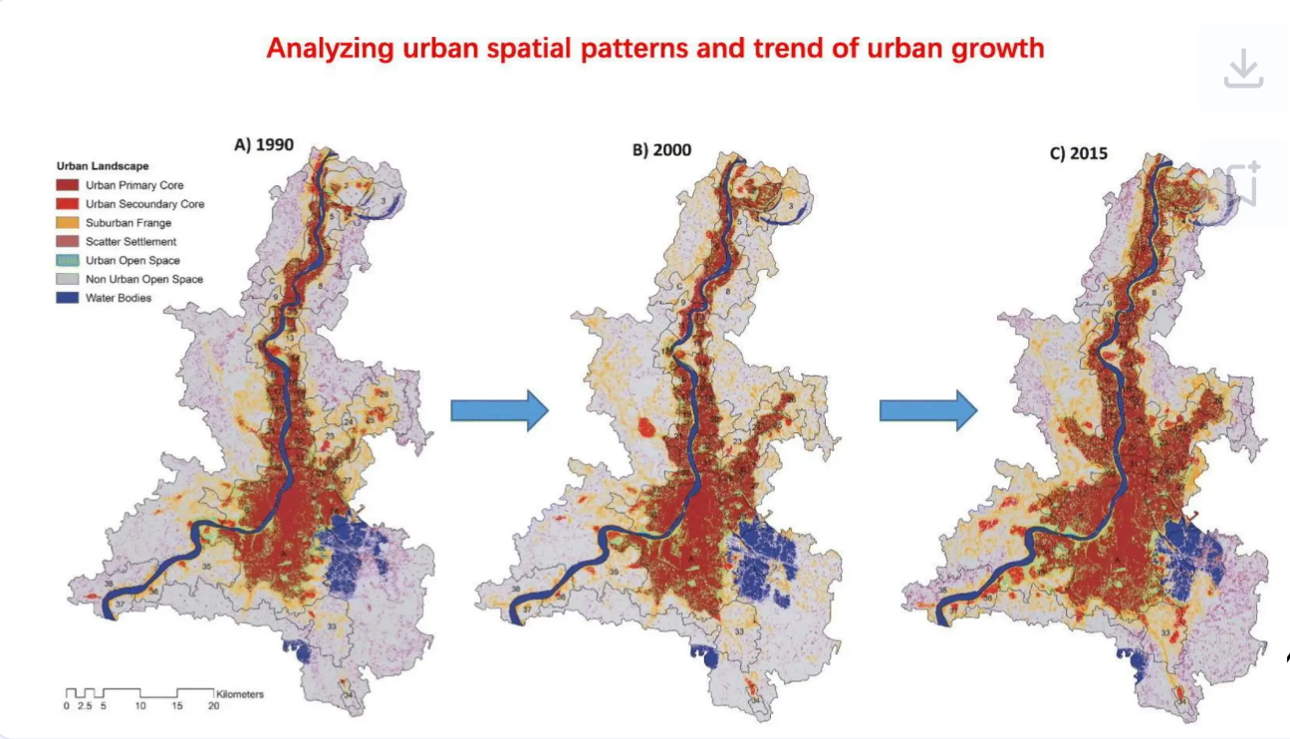

Figures above show the trend of urban growth throughout the last 3 decades in Kolkata.

***“Urban transport in Calcutta is in crisis. Because of uncontrolled land use development, associated transport activity, and an unrelenting increase in private motor vehicles, there is severe congestion and deteriorating public transport”*** (Halder,1997 p.24)

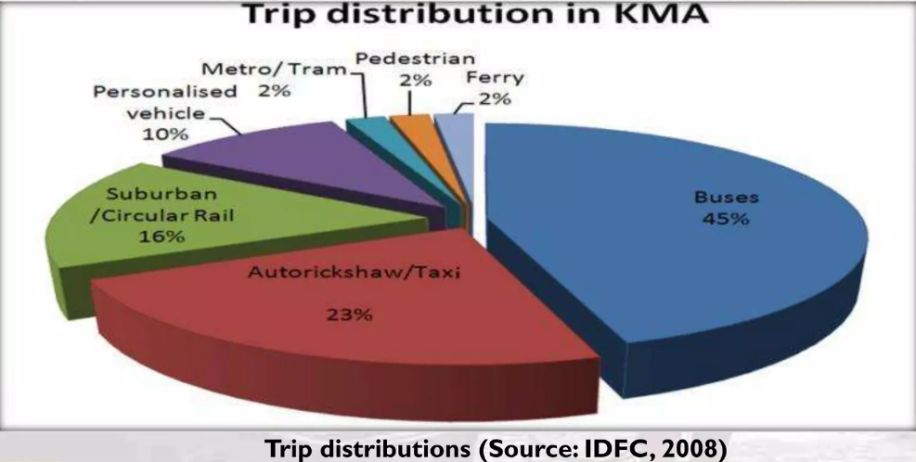

There has been an increase in population combined with successive increase in private transport as well.

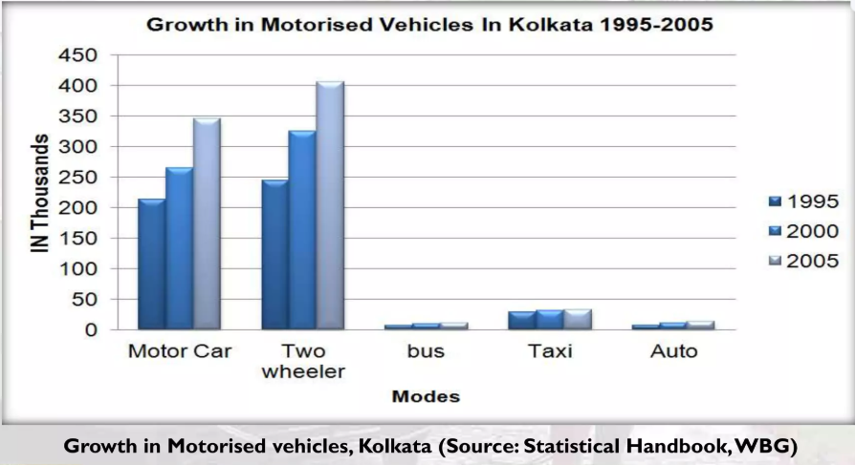

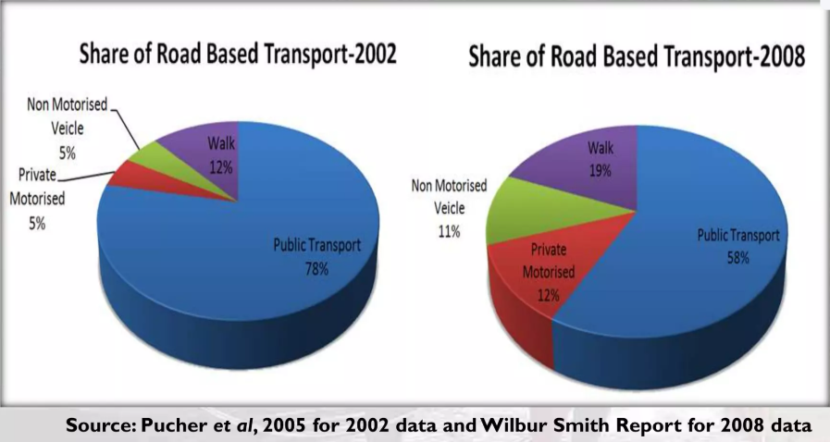

**Neighbourhood Level Urban Communities (NLUC)(A CASE STUDY)**

The concept of **Neighbourhood Level Urban Communities (NLUC)** focuses on understanding urban spaces at an intermediate level between individual buildings and city-wide infrastructure. This perspective emphasizes both the built fabric and the social and cultural characteristics of the communities within defined physical boundaries such as major roads or man-made structures. The concept was mainly introduced in the 54th ISOCARP Congress 2018.

**Key Insights:**

1. **Definition of NLUC:**
   * Represents groups of people residing within a tangible neighbourhood.
   * Defined by physical boundaries and homogeneity in built environment and character.
   * Incorporates social and cultural diversity alongside urban fabric.
2. **Purpose of NLUC Analysis:**
   * Addresses gaps in urban studies that often neglect intermediate-level assessments.
   * Examines the interplay between social structures and built environments.

**Selected NLUCs:**

The study identifies **five NLUCs** representative of different stages in Kolkata's development:

1. **Older Urban NLUCs:**
   * Core areas of Kolkata.
   * Showcase the city's colonial heritage and evolution into a modern metropolis.
   * Examples: Dhakuria, Bhowanipore.
2. **Modern NLUCs:**
   * Located in newer urban extensions of Kolkata.
   * Represent contemporary urban planning and design.
   * Examples: Salt Lake, Sukhobrishti (Newtown, Rajarhat).

**Delineation of NLUCs:**

**Five NLUCs in Delineation (Brief Explanation)**

**1. Bhowanipore**

* A historic and posh NLUC located in central Kolkata.
* Known for its mixed-use nature, combining residences, schools, markets, and shopping hubs.
* Predominantly high-income residents, with some low-income groups in slums.

**2. Dhakuria**

* A middle-income neighbourhood with a strong cultural identity.
* Famous for hosting major Durga Pujas and the vibrant Dakshinapan Shopping Complex.
* Adjacent to the culturally rich Jodhpur Park.

**3. New Garia**

* A rapidly urbanizing NLUC situated at the southern tip of the EM Bypass.
* Acts as a transport and commercial hub with major metro, bus, and railway connectivity.
* Experiencing significant commercialization due to enhanced accessibility.

**4. Salt Lake (Sector 1, BA & CA Blocks)**

* A planned satellite town developed to address population growth in Kolkata.
* Features a structured and organized layout but is often criticized for a sense of seclusion.
* Home to middle-to-higher-income groups.

**5. Rajarhat - Sukhobrishti**

* A modern gated township in New Town, Rajarhat, designed for 1 lakh residents.
* Represents contemporary urban planning with amenities for LIG and MIG groups.
* Largest mass housing project in India, emphasizing high-rise living.

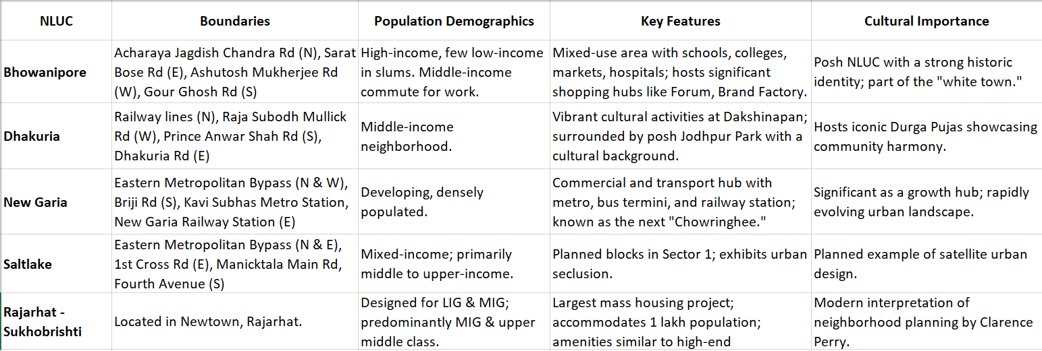

The **Imageability and Visual Survey** assessed the spatial and visual characteristics of five Neighbourhood Level Urban Communities (NLUCs) in Kolkata using Kevin Lynch's elements: **Path**, **Edge**, **District**, **Node**, and **Landmark**. It also considered factors like **pattern**, **texture**, **grain**, **density**, **building condition**, and **land use**. Key findings:

* **Community Interaction**: Bhowanipore and Dhakuria are vibrant with high street activity, while Salt Lake and Sukhobrishti are quieter and more isolated.
* **Land Use**: Bhowanipore is commercial, others are mainly residential.
* **Architecture & Diversity**: Bhowanipore has mixed colonial and modern styles, while others are more contemporary.
* **Socio-Economics**: Bhowanipore is high-income, Salt Lake and Sukhobrishti house upper-middle-class, and Dhakuria and New Garia have middle-income populations.
* **Cultural Connections**: Dhakuria and Bhowanipore have strong community engagement, unlike Salt Lake and Sukhobrishti.

The survey used a **Likert scale** to assess residents' perceptions, with scores ranging from **1 (very low)** to **5 (very high)**, on factors like **neighbourhood appeal**, **sense of community**, and **overall quality of life**. The survey's findings provided a deeper insight into how the different NLUCs in Kolkata are experienced by their residents and helped identify strengths and weaknesses in the urban design and community engagement in these areas.

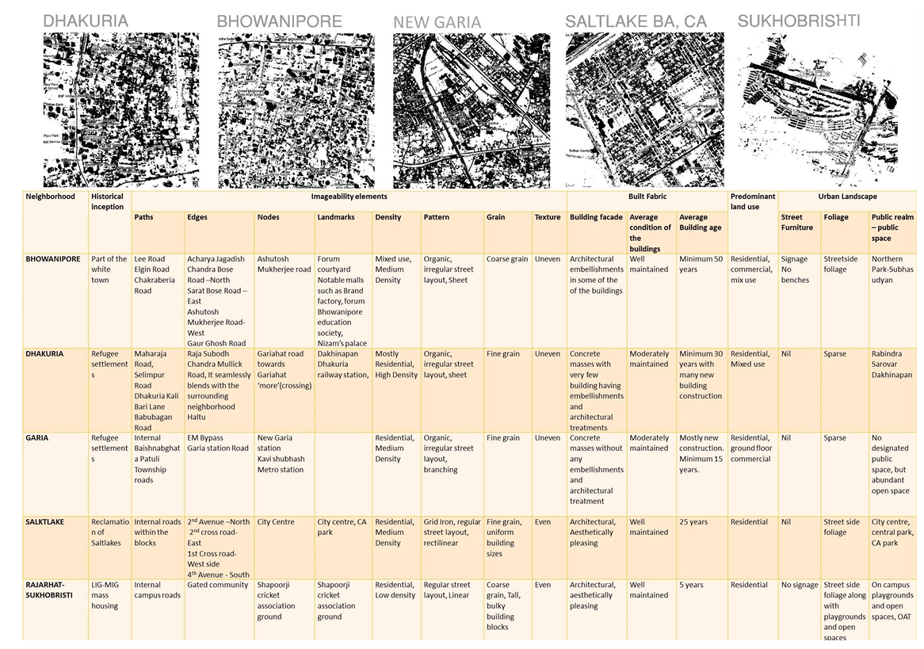

**Score Matrix based on Observations:**

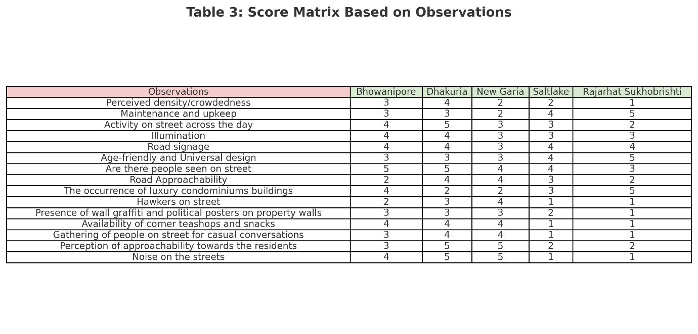

**Score Matrix based on Perception:**

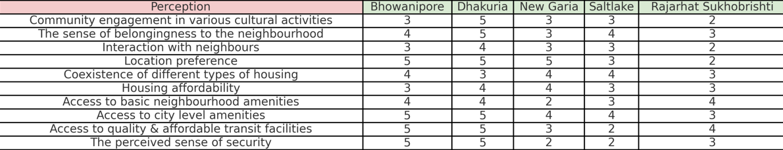

New Garia struggles with poor maintenance and infrastructure, while Saltlake and Bhowanipore are well-connected and established. Sukhobrishti is self-sufficient but isolated from its surroundings, whereas Dhakuria excels in cohesion, affordability, and cultural engagement.

Current distribution of transport network in Kolkata:

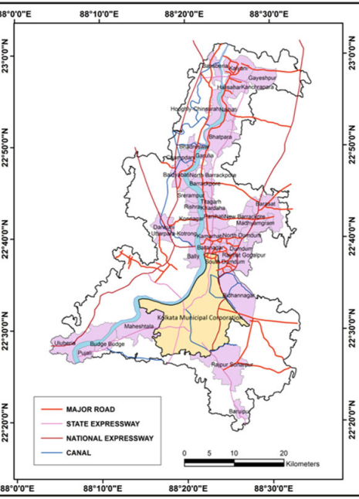

To analyse Kolkata’s issues, satellite images of Landsat 2019(Landsat OLI8) were used. Parameters used:

* **Landsat TOA Spectral Radiance (Lλ)**: Calculated using the formula

 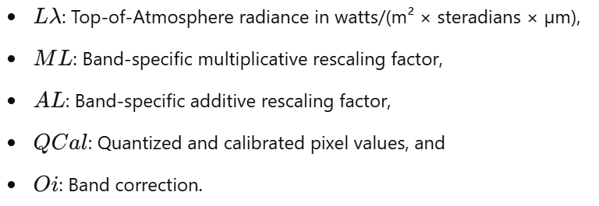

* 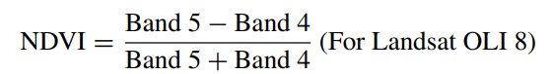**Normalized Difference Vegetation Index (NDVI)**: Used to determine vegetation coverage. NDVI is related to leaf area, canopy coverage, and chlorophyll density.

Following demographics shows the number of registered vehicles in successive years: 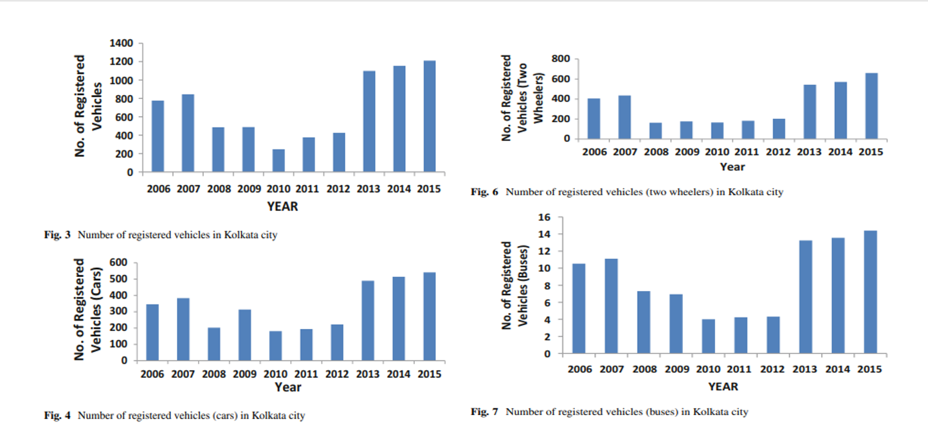

Kolkata has experienced an increase in two-wheelers and light vehicles, particularly since 2013, with a peak in 2015. This growth, combined with unplanned development in fringe areas, has led to issues like traffic congestion and road accidents. Public transport services, including buses operated by CSTC and SBSTC, have expanded to accommodate more passengers, helping to reduce congestion during peak hours.

Government initiatives, such as "Gatidhara" and the introduction of cab services like Ola and Uber, have contributed to the rise in taxis. However, the surge in vehicles has raised land surface and air temperatures, especially in core areas like Dalhousie, Dharmatala, and Park Street, due to the high density of metalled roads and vehicles. These areas now exhibit heat island effects, threatening urban sustainability.

Additionally, central Kolkata has limited vegetation, exacerbating ecological imbalance and elevating temperatures, which negatively impact local land resources and urban ecology.

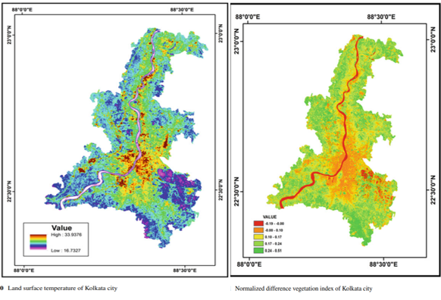**1. Integrated Traffic Management and Pedestrianization (Esplanade)**

* **Pedestrian Zones:**
  + Convert Lindsay Street and parts of Chowringhee into car-free zones during peak hours, supported by barricades and designated entry points.
* **Vending Zones:**
  + Relocate street vendors to structured markets like New Market annex areas, ensuring they have infrastructure such as covered stalls and utilities.
* **ITS Deployment:**
  + Install adaptive traffic signals with cameras and sensors to dynamically adjust timings based on real-time traffic volume.
  + Add countdown timers and traffic violation detectors for enhanced regulation.
* **Enhanced Transit Hubs:**
  + Renovate Esplanade bus terminus and tram depot into multimodal hubs with seamless Metro, bus, and tram connectivity using unified fare systems.

**2. Transit-Oriented Development (Howrah and Salt Lake)**

* **Multimodal Hubs:**
  + Build integrated hubs at Howrah Station and Salt Lake Sector V with facilities such as parking decks, skywalks, and Metro-bus connectivity points.
* **Unified Ticketing Systems:**
  + Implement smart cards and mobile apps enabling commuters to switch seamlessly between Metro, buses, and ferries.
* **Structured Parking:**
  + Establish multilevel parking garages near Howrah and Sector V to eliminate roadside parking, with real-time space availability displays.
* **Safety Measures:**
  + Construct skywalks at Howrah Station and Sector V intersections for pedestrians, complete with escalators, elevators, and covered walkways.
* **Regulated Informal Transport:**
  + Formalize shared auto-rickshaw routes and enforce fare limits using GPS-tracking systems for operational oversight.

**3. Smart Mobility and Green Corridors (Rajarhat and New Town)**

* **Bus Rapid Transit (BRT):**
  + Construct dedicated BRT lanes on arterial roads with express services to reduce congestion during office hours.
* **Cycling and Walking:**
  + Develop green corridors with dedicated cycling tracks and shaded pedestrian paths, connecting key areas like Eco Park, financial hubs, and residential zones.
* **EV Charging Infrastructure:**
  + Install EV charging stations at strategic points, such as public parking lots and residential complexes.
* **Real-Time Apps:**
  + Launch mobility apps showing live bus schedules, available routes, and EV charger locations to optimize commuter decisions.

**4. Intersection Redesign and Grade Separation (Shyambazar and Chingrighata)**

* **Intersection Redesign:**
  + Replace Shyambazar’s chaotic five-point crossing with a grade-separated flyover for through-traffic, maintaining service roads for local vehicles.
* **Pedestrian Facilities:**
  + Construct underpasses at Chingrighata with clear signage and ramps for accessibility.
* **Dynamic Signal Coordination:**
  + Synchronize traffic signals on feeder roads using real-time monitoring and adaptive algorithms to ensure steady vehicle flow.
* **Roundabouts:**
  + Introduce roundabouts where feasible to reduce vehicle stoppages and improve flow efficiency.

**5. Low Emission Zones and Eco-Transport Corridors (Howrah Bridge)**

* **Low-Emission Zones:**
  + Restrict diesel and older vehicles on Howrah Bridge during peak hours and enforce stricter emission tests.
* **Tram and Ferry Expansion:**
  + Reintroduce tram lines near Howrah and extend ferry services along the Hooghly River with increased frequency and capacity.
* **Green Buffers:**
  + Plant native tree species along key roads, particularly around Howrah Bridge and Vidyasagar Setu, to act as pollution sinks.

**6. Accelerated Project Management Framework (East-West Metro Corridor)**

* **Phased Openings:**
  + Open completed sections like Salt Lake to Sealdah for immediate use, while completing tunneling work for Howrah sections.
* **Public-Private Partnerships (PPPs):**
  + Engage private firms in financing and managing construction phases to overcome bottlenecks.
* **Advanced Technologies:**
  + Use tunnel-boring machines (TBMs) with real-time monitoring for faster and safer tunneling under the Hooghly River.
* **Transparent Reporting:**
  + Maintain public dashboards displaying project timelines, budgets, and progress to build accountability and stakeholder trust.

**Comparison of Kolkata with other states:**

As Indian cities continue to urbanize rapidly, understanding how land is allocated to road infrastructure becomes crucial for sustainable urban planning. This section presents a comparative analysis of road area coverage across major Indian cities, with a particular emphasis on **Kolkata's position relative to others**. By examining detailed breakdowns of road classifications—such as primary, secondary, and trunk roads including their links—this analysis evaluates the total transport area and its proportion to the overall city area. The cities compared include Bangalore, Mumbai, Chennai, Hyderabad, Ahmedabad, New Delhi, and Lucknow, offering a diverse cross-section of urban forms and transport planning strategies. The percentage of total area occupied by roads serves as a key metric for understanding urban density, infrastructure prioritization, and potential challenges in mobility and land use. Kolkata, despite its dense urban fabric, reflects a relatively moderate transport area share, inviting further discussion on historical infrastructure constraints and modern planning efforts.

As part of this study, I have extracted high-resolution vector maps of eight major Indian cities using the [BBBike.org](https://extract.bbbike.org/) platform, a reliable source for OpenStreetMap (OSM)-based GIS data. Each map includes not only the Central Business District (CBD) but also selected satellite areas and peripheral zones to ensure a more comprehensive spatial representation of the urban extent. This approach allows for a holistic analysis of both core urban infrastructure and its expanding suburban contexts, which are increasingly relevant in the study of metropolitan growth, road coverage, and transport planning. The cities chosen—spanning different geographic regions and urban typologies—provide a rich comparative framework for evaluating variations in road network density, land allocation patterns, and development priorities across India’s urban landscape.

For the spatial analysis, I utilized the roads.shp shapefile extracted from the downloaded dataset of each city, obtained via **BBBike.org**. These shapefiles were imported into **QGIS**, an open-source Geographic Information System, where further geospatial processing and attribute filtering were conducted. Since this study primarily focuses on **major urban thoroughfares**, we limited our analysis to roads categorized as **‘primary’, ‘secondary’, and ‘trunk’**, along with their respective **link roads**—‘primary_link’, ‘secondary_link’, and ‘trunk_link’. These categories typically represent the **key structural arteries** of a city's road network, facilitating high-capacity and inter-zonal movement. All other road classifications—such as tertiary,residential, service, or pedestrian paths—were excluded to maintain analytical clarity and consistency with the paper’s emphasis on primary transport infrastructure. Colours assigned are 1)primary- orange 2)primary_link-red 3)secondary-pink 4)secondary_link-violet 5)trunk-light green 6)trunk_link-deep green

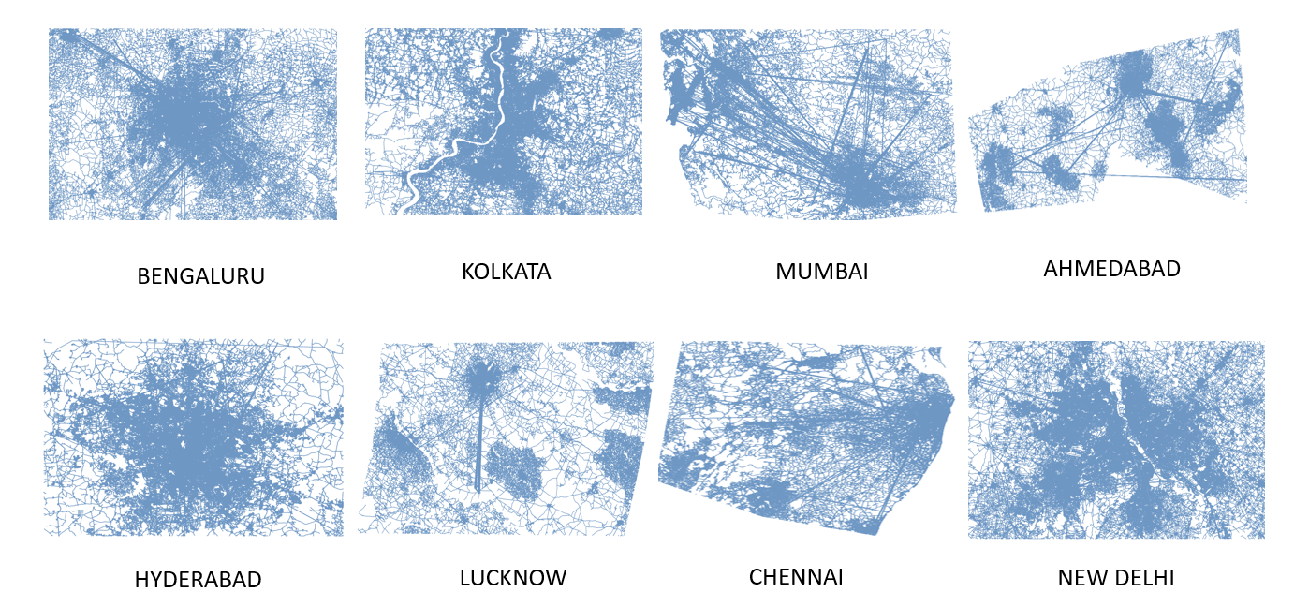

**PRE-PROCESSED MAPS**

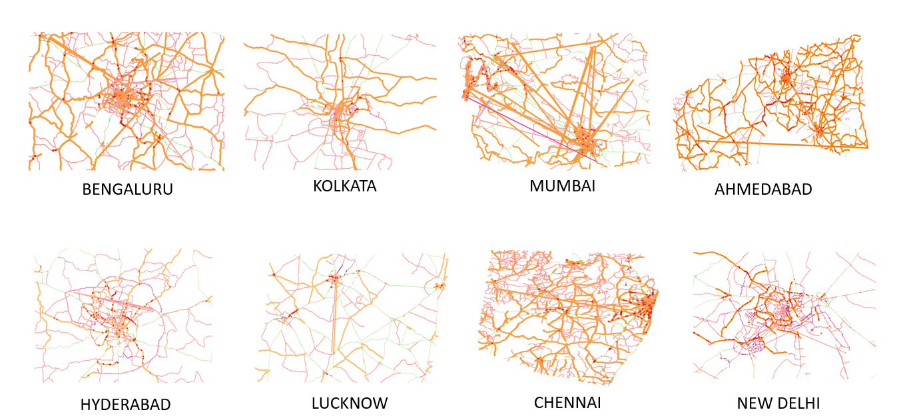

**MAPS AFTER PROCESSING**

While **QGIS** provides straightforward tools to calculate the **length** of linear features such as roads, my analysis required determining the **area occupied by road infrastructure** within each city segment. To achieve this, I developed a custom **Python script** to calculate the **total area covered by the selected road classes**, as well as the **total area of the city segment** extracted. This was essential for quantifying the **percentage of land** dedicated to major roads in each urban region.

Since this study required calculating not just the **length** but the **area occupied by road infrastructure** in each city, it was essential to ensure accurate spatial measurements. While **QGIS** is equipped to measure lengths directly from shapefiles, calculating areas (especially in square meters) requires the data to be projected in a **planar coordinate system**. The default **WGS 84 geographic coordinate system (EPSG:4326)** expresses locations in degrees, which is not suitable for reliable area calculations due to distortion and the curvature of the Earth.

To address this, all city shapefiles were reprojected into the **Universal Transverse Mercator (UTM)** system, which divides the Earth into 6-degree longitudinal zones and expresses coordinates in meters. This makes UTM ideal for **regional spatial analysis**, such as computing the surface area covered by roads or determining the proportion of land used for transport infrastructure.

Each city was assigned an appropriate **EPSG code**, which uniquely identifies the projection system used. For Indian cities, the following UTM zones and EPSG codes are commonly applied:

| **UTM Zone** | **EPSG Code** | **Cities Covered** |
| --- | --- | --- |
| **42N** | 32642 | Western Gujarat, Mumbai |
| **43N** | 32643 | Ahmedabad, parts of Rajasthan and Maharashtra |
| **44N** | 32644 | Hyderabad, Chennai, Bangalore |
| **45N** | 32645 | Kolkata, Lucknow, Patna |
| **46N** | 32646 | Assam, Northeast India |

For example, **Kolkata** was reprojected using **EPSG:32645**, corresponding to **UTM Zone 45N**, ensuring that area measurements were accurate and in square meters. Similarly, **Hyderabad and Bangalore** were projected using **EPSG:32644 (UTM Zone 44N)**. This reprojection process was carried out using a custom **Python script**, and it ensured a uniform standard for calculating both the **total area of each city segment** and the **area occupied by major roads** (i.e., 'primary', 'secondary', 'trunk', and their link types). This consistent projection framework was critical for producing reliable and comparable statistics across all selected Indian cities.

To quantify the area occupied by different classes of roads within the selected city maps, we used Python along with the GeoPandas library. Each city’s “roads.shp” shapefile, obtained from BBBike.org, was first loaded into the environment and reprojected to a suitable UTM coordinate reference system (EPSG:32645 for Kolkata) to ensure accurate area and length calculations. We selected six main road types—‘primary’, ‘secondary’, ‘trunk’, and their respective ‘_link’ types—since these represent major transport corridors and are the focus of our study. Standardized road widths were assigned to each category based on typical design guidelines: 10.0 m for ‘primary’, 7.0 m for ‘secondary’, ‘trunk’, and ‘primary_link’, and 5.5 m for ‘secondary_link’ and ‘trunk_link’. These widths were converted to kilometers and multiplied by the length of each road segment (also converted to kilometers) to obtain the area occupied by each road segment. The total road area was then aggregated by road type. To estimate the total area of the study segment, the “convex hull” of all road geometries was used as an approximate boundary. This allowed us to compute both the total transport area and its proportion relative to the overall map extent.

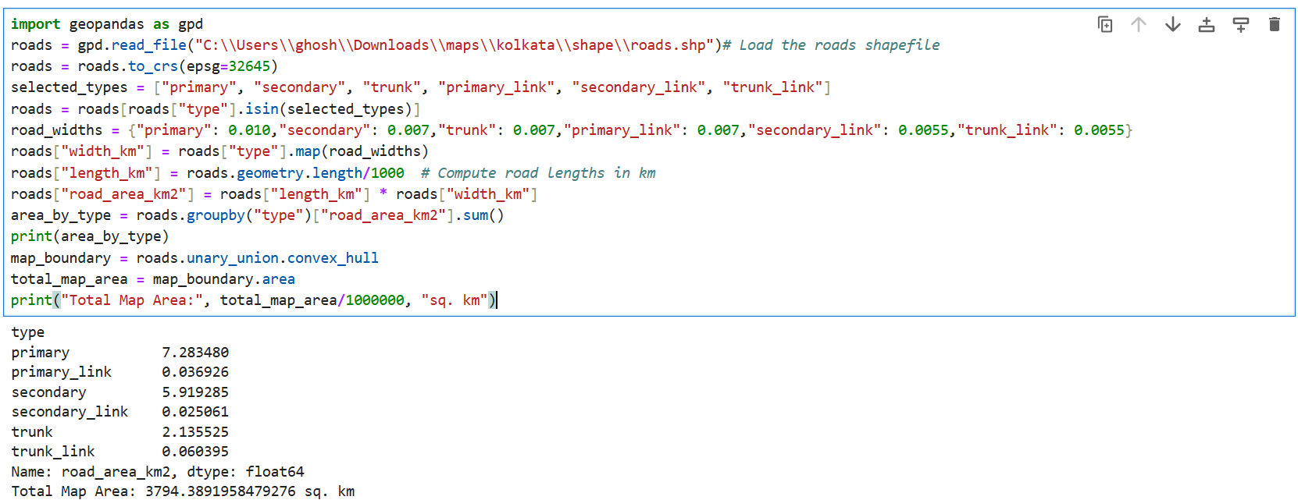

In addition to roads, **railways were also included** in the analysis as they form a significant component of urban transport infrastructure. Each city’s railways.shp shapefile was processed similarly to the road data. After reprojecting to the appropriate UTM coordinate system (EPSG:32645 for Kolkata), features classified as ‘rail’ were filtered for further computation. A standard width of **25 meters** was assigned to railway lines based on average land occupation by double-track rail corridors, including safety zones and buffer margins. The rail lengths were calculated in kilometers and multiplied by this width (converted to kilometers) to estimate the total **railway area in square kilometers**. This value was then incorporated into the overall transport area computation to provide a more holistic representation of land usage by major transportation systems in each city.

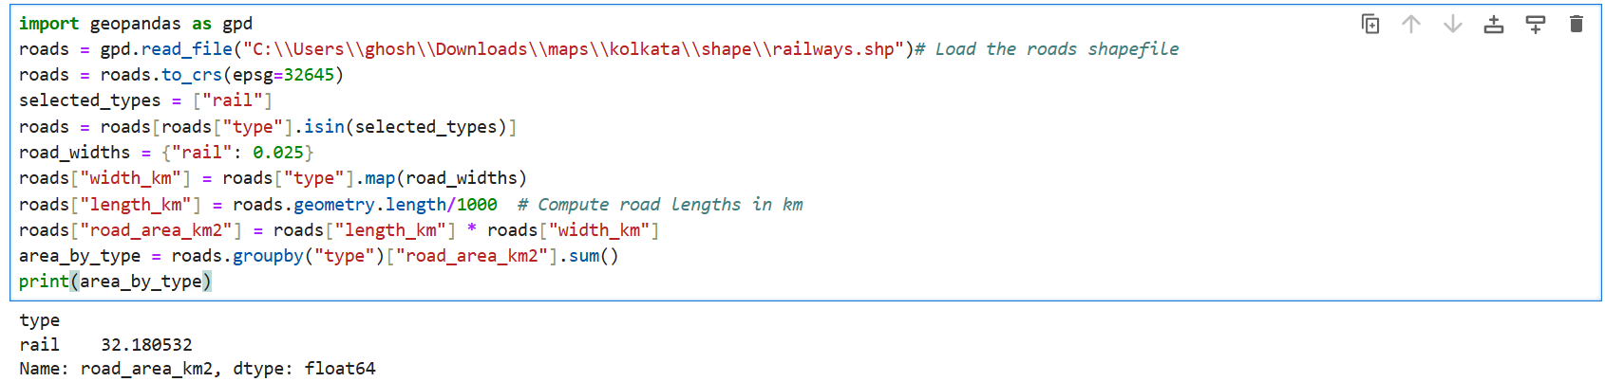

With both road and railway spatial data quantified in terms of area, we arrive at a cumulative estimate of transport land use across the selected cities. This unified approach allows for a more accurate comparison of how much urban space is allocated to major transport corridors. The processed data now sets the foundation for analyzing patterns, variations, and insights across different urban contexts in the subsequent section.

**RESULTS AND DISCUSSION:**

The calculated areas for both roadways and railways across the selected Indian cities provide insight into how much urban land is devoted to major transport infrastructure. Two sets of data were derived: one focusing solely on the classified road types—*primary*, *secondary*, *trunk*, and their respective link roads—and the other including railway corridors to account for total transport coverage. These values were then normalized against the total area of each mapped region to enable meaningful comparison.

A tabular breakdown of these metrics reveals significant inter-city variation in transport area percentages, influenced by factors such as urban density, planning structure, and transport dependency. The following tables illustrate the spatial extent of different roadway types, as well as the contribution of railway infrastructure to total transport area.

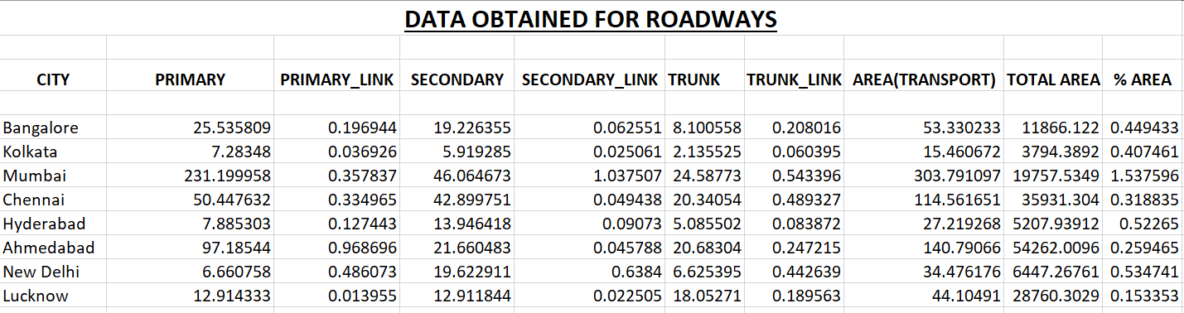

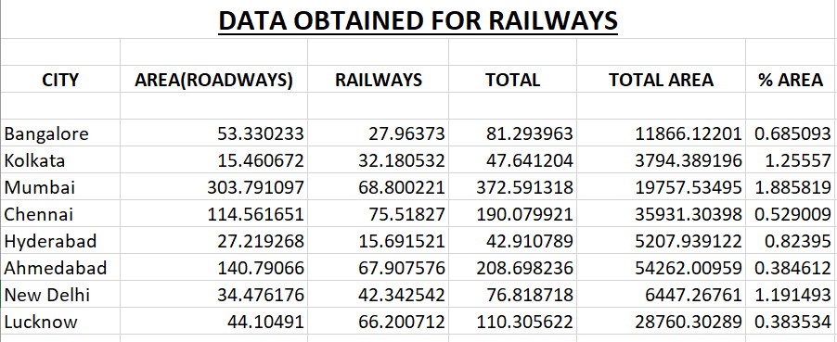

The analysis shows that Kolkata allocates approximately **15.46 km²** to road infrastructure, and **32.18 km²** to railway corridors, making a combined transport area of **47.64 km²**, which accounts for **1.26%** of the total mapped region. This is comparatively higher than cities like Chennai or Ahmedabad in terms of percentage share, despite Kolkata's relatively smaller geographic extent. Such a high density of transport infrastructure in a compact urban footprint suggests significant pressure on land availability and reflects the city’s long-standing reliance on both road and rail networks.

This also points to challenges such as congestion, limited room for road expansion, and conflicts over land use. The dense urban core and organically grown layout, unlike the planned grids of newer cities, further complicate efforts to upgrade or redesign infrastructure.

* **Mumbai** has the highest total transport area, reflecting the city’s dense urban structure and dependency on both road and rail networks to support its massive population.
* **Chennai** shows a relatively low transport area percentage despite a large mapped area, indicating a more sprawling urban form and potential space for planned development.
* **Bangalore** displays a balanced share of transport infrastructure but continues to face severe congestion due to rapid growth and limited road capacity expansion.
* **Hyderabad** has a moderate transport area with a higher proportion allocated to roads, highlighting its recent investments in road infrastructure and ongoing metro development.
* **Ahmedabad** presents a low percentage of transport coverage, likely due to its planned urban grid and early adoption of efficient transit systems like BRTS.
* **New Delhi** has a high transport density in a relatively compact area, consistent with its role as the national capital with wide roads and extensive rail and metro services.
* **Lucknow** reflects one of the lowest transport area percentages, suggesting a less developed network that is gradually expanding with recent infrastructure projects.

A comparative visual analysis of road networks across eight major Indian cities reveals significant spatial and structural variations in urban transport infrastructure. By examining both the full spectrum of road types and isolating only the primary networks, key observations regarding city planning and mobility can be drawn.

In **Bengaluru**, the road network demonstrates a highly dense and expansive configuration, with a clear radial and ring road pattern emerging when focusing solely on major roads. This suggests a well-planned outward expansion from the core, supported by a robust arterial framework.

**Kolkata** displays a concentrated and irregular mesh of roads, particularly intensified near the Hooghly River. While the complete dataset reveals a complex fabric of local streets, the major road network appears sparse and fragmented. The city's linear development along the river and the limited presence of primary and secondary roads indicate a heavy reliance on narrower, localized routes.

The transport network in **Mumbai** is distinctly linear, following a north-south orientation that aligns with the city's coastal geography. Even though the full road data shows a tightly interwoven structure of roads, the major road network is composed of well-defined arterial corridors. This reflects strong backbone connectivity that has developed within severe spatial constraints.

**Ahmedabad** presents a relatively structured urban form, with major roads forming radial arms and ring-like formations that interconnect its decentralized industrial and residential clusters. While local road density is moderate, the major transport corridors suggest a well-conceived urban grid.

In **Hyderabad**, the road network is characterized by a dense core and expansive peripheries. The major roads clearly reflect a radial-rink configuration, with the presence of multiple circular routes. This indicates a proactive approach to long-term planning and an effective distribution of transport demand across the metropolitan area.

**Lucknow** shows a compact and moderately dense road network, with a single strong central node extending into branches. The limited presence of high-capacity roads compared to the total network reveals a dependence on smaller streets and underscores the potential need for expanded arterial connectivity.

**Chennai** demonstrates an asymmetrical sprawl, particularly towards the southern and western regions. The major road network includes several strong highway arteries and curved connectors, though the city’s eastern expansion is limited by its coastal boundary. A relatively well-structured grid is evident in the western suburbs, suggesting planned growth in that direction.

Finally, **New Delhi** features the most complex and layered road system among the analyzed cities. The major road network forms a dense web, underscored by multiple ring and radial roads that facilitate efficient movement. This hierarchy of roads stands out for its clarity and density, reflecting the city’s planned development and administrative significance.

These comparative spatial patterns highlight both geographical influences and varying degrees of urban planning across Indian metropolitan regions. The degree of arterial development plays a crucial role in shaping urban accessibility and directly impacts challenges related to congestion, connectivity, and future infrastructure expansion.

### 

**Kolkata’s Road Network:**

The spatial configuration of Kolkata’s road infrastructure reveals a dense but fragmented pattern, shaped significantly by the city’s historical evolution and its geographical context. The analysis of the complete road dataset exhibits a tight mesh of minor and local roads, particularly concentrated around the central core and along the Hooghly River. This pattern reflects the organic, incremental development of the city over time, characterized by narrow streets, unplanned settlements, and a limited capacity for expansion in certain directions.

When isolating the primary, secondary, and trunk road categories, a notable scarcity of major thoroughfares becomes apparent. The city lacks an extensive network of broad arterial roads that can facilitate efficient movement across zones. Major routes appear sporadically, mostly branching from the central business district and stretching linearly along the riverbanks. The absence of a strong radial or ring structure in the major roads underscores a critical challenge in Kolkata’s urban transport planning—namely, the overreliance on minor roads for both local and through traffic.

This fragmented structure has several implications. Firstly, the low share of land dedicated to primary and secondary roads restricts vehicular movement, particularly during peak hours. Secondly, the lack of hierarchical connectivity limits the integration of peripheral areas, reinforcing spatial inequality. Finally, the influence of the river continues to shape the urban form, funneling traffic along constrained north-south corridors and limiting lateral expansion.

Compared to other major Indian cities, Kolkata's transport network demonstrates a relatively low area coverage for both roadways and major corridors. This results in higher pressure on existing routes and necessitates a re-evaluation of urban transport policies—especially in terms of land reallocation, widening of strategic corridors, and the integration of multimodal systems. Without significant infrastructural interventions, the current configuration is likely to exacerbate congestion, reduce accessibility, and hinder sustainable urban growth.

Additionally, the railway network in Kolkata occupies a larger area than the roadways themselves, as revealed in the spatial analysis. This extensive railway footprint reflects the city's long-standing dependency on suburban and intra-city rail transit. While this is a strength in terms of public transportation accessibility, it simultaneously poses spatial challenges for surface-level planning. The physical presence of rail lines cuts through many neighborhoods, affecting road continuity and urban form.

Drawing from the study *"Analysis of transformation of urban planning practice by mapping changes in economic, social, cultural and built environment of the Neighborhood Level Urban Communities (NLUC): Case study of Kolkata, India"* by Sudeshna Kumar and Haimanti Banerjee, several critical insights emerge that reinforce the findings of the transport analysis:

* **Organic Growth over Planned Expansion**: Most NLUCs in Kolkata have emerged organically, particularly in peripheral and semi-peripheral areas. This organic development was seldom guided by a structured master plan, resulting in highly heterogeneous urban forms.
* **Land Use–Transport Disconnect**: The expansion of built environments within many NLUCs has not been matched with proportional transport infrastructure. This mismatch leads to severe accessibility issues and congestion, as minor roads within these communities are often burdened with traffic they were never designed to handle.
* **Fragmented Urban Form**: The morphology of NLUCs is typically compact but fragmented. Mixed land uses, narrow lanes, and irregular plot development dominate these zones, leaving little room for infrastructure upgrades or the introduction of high-capacity roadways.
* **Dependence on Non-Motorized and Rail-Based Transit**: Many of these communities depend heavily on suburban rail services and non-motorized transport modes like cycling and walking. While sustainable in theory, this over-reliance often occurs in the absence of last-mile connectivity, making the system inefficient during peak hours.
* **Cultural and Economic Constraints**: Socio-cultural factors play a strong role in how space is utilized within NLUCs. Community-specific practices influence street width, shared spaces, and land subdivision, which often limits the ability to implement standardized urban design principles.
* **Challenges in Retrofitting**: The irregular and compact spatial patterns within NLUCs make retrofitting of wide roads or modern transport corridors highly challenging without mass displacement or complex redevelopment schemes.

According to the Kolkata Police Review Report (2022), the city spans an area of **311.68 sq. km** and maintains a total road length of **4,018 km**, serving a registered vehicle population of over **5 million (50,46,330)**. When compared with other Indian metros, Kolkata stands out for having one of the **highest vehicular densities per kilometer of road**, despite having a relatively smaller geographic area.

According to Kolkata Police Review Report (2022) :

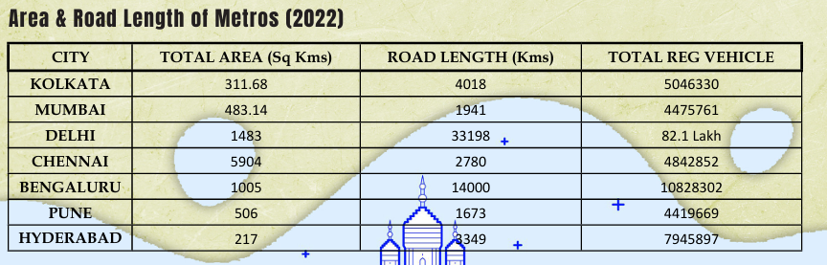

An assessment of macro-level urban transport indicators—such as **total road length, urban area, and registered vehicle count**—provides deeper insights into the infrastructural stress faced by Kolkata in comparison to other major Indian cities.

According to the 2022 data:

* **Kolkata**, with a total area of **311.68 sq. km** and a road length of **4018 km**, supports over **5 million registered vehicles**.
* Despite being the **smallest** among the compared metros in terms of area, it exhibits one of the **highest vehicular densities per kilometer of road**, far surpassing cities like Mumbai (1941 km of roads), Pune (1673 km), and even Delhi (33198 km of roads).
* **Delhi** has over **8.2 million vehicles**, but the pressure is distributed across a significantly larger network of **33198 km** of roads over **1483 sq. km**, leading to relatively lower road stress.
* **Bengaluru**, with **108 lakh** vehicles and **14000 km** of road length, also experiences high traffic pressure, but its larger urban expanse (**1005 sq. km**) allows for better absorption of that load spatially.

What emerges is a clear case of **road network saturation in Kolkata**. While cities like Chennai and Hyderabad may have comparable or even higher vehicle numbers, Kolkata's **smaller land area** and **relatively short total road length** result in a transport environment that is **intensely congested and spatially constrained**.

This comparison highlights two major challenges for Kolkata:

1. **Intensive vehicular pressure on limited road space** – with over 1,250 vehicles per kilometer of road, Kolkata experiences significant congestion, compounded by narrow streets and limited road width in many areas.
2. **Disproportionate vehicle growth vs. infrastructure expansion** – While the number of vehicles has surged over the years, road length has remained relatively stagnant, resulting in an increasingly strained transport network.

These findings reinforce earlier spatial analysis and align with the conclusion that **Kolkata’s urban mobility suffers not from lack of coverage, but from a lack of capacity and structural hierarchy in road design**. The absence of broad arterial roads, coupled with uncontrolled vehicular growth, poses severe challenges for traffic management and sustainable urban transport.

**Suggestions and the Way Forward**

While the analysis reveals considerable pressure on Kolkata’s transport infrastructure—particularly due to its limited road area and high vehicular density—the findings also open avenues for thoughtful urban interventions that can shape a more efficient and resilient city.

1. **Prioritize Public and Mass Transit Expansion**  
   Kolkata already has a strong foundation in public transit, including its metro system and bus network. Strategic expansion of metro lines into underserved areas, improved interconnectivity, and promotion of last-mile connectivity options (like e-rickshaws and shuttle buses) can significantly ease road congestion.
2. **Revitalize and Optimize Road Infrastructure**  
   Instead of large-scale road expansion—which is limited by land availability—efforts can focus on optimizing existing road space. This includes better traffic signaling, intelligent traffic management systems, dedicated bus lanes, and improved junction design to ensure smoother flow.
3. **Promote Non-Motorized Transport (NMT)**  
   Kolkata’s compact urban form makes it ideal for pedestrianization and cycling. Investing in safe, well-lit footpaths, protected cycle lanes, and car-free zones can reduce local traffic and promote healthier, eco-friendly mobility.
4. **Land Use–Transport Integration**  
   Following the principles explored in the NLUC study, urban development should integrate transportation access with housing, markets, and services. Transit-Oriented Development (TOD) policies can ensure high-density, mixed-use development around metro corridors, making public transit the default mobility choice.
5. **Leverage Smart Technologies**  
   Embracing digital solutions like real-time traffic updates, digital parking systems, and smart mobility apps can help manage demand, reduce travel times, and enhance the commuter experience.
6. **Community-Based Urban Planning**  
   Engaging local communities in planning processes ensures context-sensitive designs that reflect the lived realities of Kolkata's diverse neighborhoods. Community inputs can help identify bottlenecks, optimize informal transit, and design inclusive spaces.
7. **Sustainable Urban Mobility Plans (SUMPs)**  
   Adopting SUMPs tailored for Kolkata can align transport planning with environmental, social, and economic goals. This includes emission control zones, promotion of electric vehicles, and policies to discourage excessive private vehicle use.

Despite its spatial and infrastructural constraints, Kolkata stands at a unique juncture—blending historical urban patterns with modern mobility potential. By leveraging its strong public transit culture, community-oriented planning tradition, and compact urban fabric, Kolkata can emerge as a model for sustainable urban mobility in India.

**CONCLUDING REMARKS:**

The analysis undertaken in this study highlights the complex and evolving challenges associated with urban transport planning in Kolkata. Compared to other major Indian metropolitan cities, Kolkata stands out for its lower road area percentage, high vehicular concentration, and relatively compact administrative boundary. While the city possesses a dense network of smaller roads, it lacks an extensive coverage of primary and secondary roadways, resulting in bottlenecks, uneven accessibility, and constraints in efficient urban mobility. The limited area allocated to transportation infrastructure, compounded by rapid motorization, reflects an urgent need for systematic intervention.

From a **policy perspective**, there is a pressing need for integrated, long-term urban transport frameworks that transcend departmental silos. Policy efforts must prioritize the expansion and modernization of Kolkata’s arterial road network, while promoting multimodal connectivity that includes the railway and metro systems. Alignment with national urban development schemes can provide the necessary financial and institutional support to guide future growth.

In terms of **environmental planning**, the current patterns of road and transport infrastructure development must be critically re-evaluated. The high vehicle density and constrained road coverage contribute significantly to air pollution, noise, and carbon emissions. Incorporating green infrastructure, non-motorized transport, and climate-sensitive design into the urban mobility fabric will be essential in ensuring sustainable urban futures. Environmental impact assessments and nature-based solutions should be institutionalized within planning processes to mitigate the ecological footprint of expanding transport networks.

Finally, a **citizen-centric approach** must be embedded within urban planning processes. Equitable access to transportation services, especially for marginalized and transit-deprived communities, is fundamental to ensuring inclusive growth. Encouraging public participation, integrating informal transport systems, and enhancing last-mile connectivity will improve the usability and reliability of transport networks. Technological tools such as mobile-based travel information systems and feedback platforms can further bridge the gap between governance and daily commuter experience.

In sum, Kolkata’s transport challenges reflect both spatial constraints and systemic planning gaps. However, these challenges also present a critical opportunity to redefine urban mobility through resilient, inclusive, and forward-looking planning practices. With data-backed insights and citizen-oriented policy instruments, Kolkata can realign its urban growth trajectory to ensure a more connected, sustainable, and livable future.

**REFERENCES:**

* *Vijayalakshmi, S., & Krishna Raj, R. (2019). Sustainable Urban Transport Indicators: Case of Mega Cities of India.* ***Journal of Urban and Regional Studies****, 12(2), 103–118.*
* *Ghose, M. K., Paul, R., & Banerjee, S. K. (2004). Assessment of the impacts of vehicular emissions on urban air quality and its management in Indian context: the case of Kolkata (Calcutta).* ***Environmental Science & Policy****, 7(4), 345–351.* [*https://doi.org/10.1016/j.envsci.2004.06.004*](https://doi.org/10.1016/j.envsci.2004.06.004)
* *Majumdar, S. (2016). Prospects of Sustainable Transport of Automobile Vehicles in Kolkata City.* ***International Journal of Engineering Research and Applications (IJERA)****, 6(1), 13–19--Examines the challenges and opportunities for eco-friendly vehicle adoption in the congested urban core of Kolkata.*
* *Bhattacharya, S. (2017). What is impeding implementation of Sustainable Urban Transport Policy? A Case Study of Policy Implementation in Kolkata, India.* ***International Journal of Urban Planning and Policy****, 11(1), 21–38.*
* *Kumar, Sudeshna, & Banerjee, Haimanti. (2021). Analysis of transformation of urban planning practice by mapping changes in economic, social, cultural and built environment of the Neighborhood Level Urban Communities (NLUC): Case study of Kolkata, India.* ***Journal of Urban Studies and Development****, 15(3), 241–260.*
* *Bhattacharya, S. (2019). Urban Transport - Kolkata: A Review.* ***Journal of Urban Transport Systems****, 7(2), 72–89.  
  A comprehensive overview of current urban transport infrastructure and modal splits in Kolkata.*
* *Majumdar, S. (2020). Para-Transit Modes: A Boon or Bane of Kolkata City.* ***International Journal of Scientific Research and Reviews****, 9(3), 552–561.  
  Explores informal transit services such as auto-rickshaws and shared taxis and their role in bridging accessibility gaps.*
* *Blum, A. (2007). HQE2R—Research and Demonstration for Assessing Sustainable Neighborhood Development. In* ***Sustainable Urban Development****, Vol. 2, pp. 412–428. Springer.* [*https://doi.org/10.1007/978-3-540-71168-3_28*](https://doi.org/10.1007/978-3-540-71168-3_28) *Describes the HQE2R project focusing on quality and environmental sustainability at neighborhood levels.*
* *Bidhannagar Municipal Corporation. (2018). BMC Profile – Urban Overview and Governance Framework.* [*http://www.bmcwbgov.in/index.php/about-us/bmc-profile*](http://www.bmcwbgov.in/index.php/about-us/bmc-profile)
* *Chattopadhyay, Swati. (2017). Neoliberal Urban Transformations in Indian Cities: Paradoxes and Predicaments.* ***Progress in Development Studies****, 17(4), 307–321.* [*https://doi.org/10.1177/1464993417716355*](https://doi.org/10.1177/1464993417716355) *Critically analyzes the contradictions inherent in neoliberal planning practices across Indian cities, with cases from Kolkata.*
* *U.S. Environmental Protection Agency (USEPA). (2011). Guide to Sustainable Transportation Performance Measures. Washington, DC. Retrieved from* [*https://www.epa.gov/smartgrowth*](https://www.epa.gov/smartgrowth)
* *ESRI. (2017). What is GIS? A Beginner’s Guide to Geographic Information Systems. Retrieved from* [*http://www.esri.com/what-is-gis*](http://www.esri.com/what-is-gis) *A concise technical primer explaining how GIS tools are applied in urban and transport planning.*
* *Sarkar, P. K., & Tagore, P. (2011). An Approach to the Development of Sustainable Urban Transport in Kolkata.* ***Current Science****, 100(9), 1349–1361.  
  This paper proposes integrative planning and public transport restructuring tailored to Kolkata's spatial structure.*
* *Mukherjee, M. (2011). Urban Growth and Spatial Transformation of Kolkata Metropolis: A Continuation of Colonial Legacy.* ***ARPN Journal of Science and Technology****, 2, 365–380.  
  Investigates post-colonial planning trajectories and land use transformation patterns in Kolkata.*
* *IDFC. (2008). Comprehensive Mobility Plan for Kolkata Metropolitan Area (KMA): Back to Basics. Infrastructure Development Finance Company. Retrieved from* [*http://www.kmdaonline.org/pdf/CMP-KMA.pdf*](http://www.kmdaonline.org/pdf/CMP-KMA.pdf) *A city-wide diagnostic and mobility planning blueprint developed for medium-term urban transport interventions.*
* *OpenStreetMap Contributors. (2024). BBBike Extracts – Shapefiles and GIS Data for Urban Planning and Transport. Retrieved from* [*https://extract.bbbike.org/*](https://extract.bbbike.org/) *A valuable open-source spatial data platform providing downloadable city-scale shapefiles.*
* *Kolkata Traffic Police. (2022). Annual Review Report: Traffic, Safety, and Urban Mobility. Retrieved from* [*https://kolkatatrafficpolice.gov.in/*](https://kolkatatrafficpolice.gov.in/) *Summarizes annual traffic patterns, enforcement activities, and infrastructure changes.*
* *Arora, A., Dasgupta, R., & Mukherjee, T. (2025). Multimodal Integration in India: Opportunities, Challenges, and the Way Forward.* ***Case Studies on Transport Policy****. Evaluates multimodal system design with case evidence from Indian metros including Kolkata.*
* *Department of Architecture & Regional Planning, IIT Kharagpur. (2023). Integration of Bus Transit and Para-Transit Along a Network Corridor in Kolkata. Research project published via ResearchGate.*
* *Kumar, Sudeshna, & Banerjee, Haimanti. (2020). Methodology for Framing Indicators for Assessing Economic-Socio-Cultural Sustainability of Neighborhood-Level Urban Communities (NLUCs) in Kolkata, India.* ***Social Indicators Research****, 149(3), 715–740.*
* *Kumar, S., et al. (2021). Bayesian Network Modeling for Economic-Socio-Cultural Sustainability of Neighborhood-Level Urban Communities: Reflections from Kolkata, an Indian Megacity.* ***Sustainable Cities and Society****, 67, 102750.* [*https://doi.org/10.1016/j.scs.2021.102750*](https://doi.org/10.1016/j.scs.2021.102750)
* *Sarkar, P. K., et al. (2023). Achieving Sustainable Transportation System for Indian Cities – Problems and Issues.  
  A wide-ranging review of structural, institutional, and infrastructural barriers to sustainable transport.*
* *Majumdar, S., Sinha, R., & Ghosh, P. (2013). Pollutant Emissions from Road Vehicles in Mega-City Kolkata, India: Past and Present Trends. ResearchGate Working Paper.  
  Provides longitudinal data on vehicular emissions across two decades.*
* *Ghosh, S. (2024). Kolkata's Overlooked Air Pollution Crisis: Invisible Threats in the City of Joy.* ***Mongabay-India****.* [*https://india.mongabay.com*](https://india.mongabay.com) *Investigative journalism uncovering worsening pollution metrics and governance gaps.*
* *World Economic Forum. (2019). Kolkata Tackles Pollution Problem with Public Transport Solutions. Retrieved from* [*https://www.weforum.org/agenda/2019/03/kolkata-tackles-pollution-with-public-transport/*](https://www.weforum.org/agenda/2019/03/kolkata-tackles-pollution-with-public-transport/)
* *Shah, J., & Trivedi, P. (2024). Sustainable Urban Transport in India: Status, Challenges, and Solutions. ResearchGate White Paper.  
  A policy-focused document proposing interventions for last-mile connectivity and clean energy mobility.*
* *Wizardencil Blog. (2021). Sustainable Urban Mobility Plan and Trams in Kolkata: Lessons from the Past, Hope for the Future. Retrieved from* [*https://wizardencil.in/sustainable-mobility-kolkata*](https://wizardencil.in/sustainable-mobility-kolkata) *Discusses Kolkata’s unique tram system and its potential role in low-emission transport revival.*
* ***Major Project Files and Codebase. GitHub Repository. Retrieved from:***[*https://github.com/Myra1729/MAJOR_PROJECT*](https://github.com/Myra1729/MAJOR_PROJECT) *Complete source code, spatial datasets, and analysis notebooks used for project development.*

**WORK SCHEDULE:**

| **Month** | **Activities** |
| --- | --- |
| **August 2024** | - Finalize project topic and objectives.  - Conduct preliminary literature review.  - Develop detailed project proposal.  - Submit project proposal for approval. |
| **September 2024** | - Conduct in-depth literature review.  - Identify key problems in urban planning.  - Collect data and resources for analysis. |
| **October 2024** | - Analyze collected data.  - Begin drafting sections of the report (Introduction, Literature Review).  - Prepare initial findings and discussions. |
| **November 2024** | - Continue drafting report (Problem Identified, Objectives, Scope).  - Start compiling results and discussions. |
| **January 2025** | - Finalize results and discussions.  - Draft conclusion and recommendations. |
| **February 2025** | - Review and revise the entire report.  - Prepare presentation materials. |
| **March 2025** | - Submit the final report for review.  - Incorporate feedback from supervisor and peers. |
| **April 2025** | - Finalize the report based on feedback.  - Present findings to the department.  - Submit all required documentation and project work. |